**MODERN DATABASE SYSTEM LAB 8**

**UNIVERSITY COURSE ENROLLMENT DATA ANAYTICS**

**NAME: PAVITHIRAN.V ROLL.NO: 235229122**

**Question 1**:

SELECT p.PNAME

FROM prof_data p

INNER JOIN dept_data d ON p.DNAME = d.DNAME

LEFT JOIN (SELECT DNAME, COUNT(*) AS NUM_PHD

FROM major_data

GROUP BY DNAME) m ON d.DNAME = m.DNAME

WHERE m.NUM_PHD < 50 OR m.NUM_PHD IS NULL;

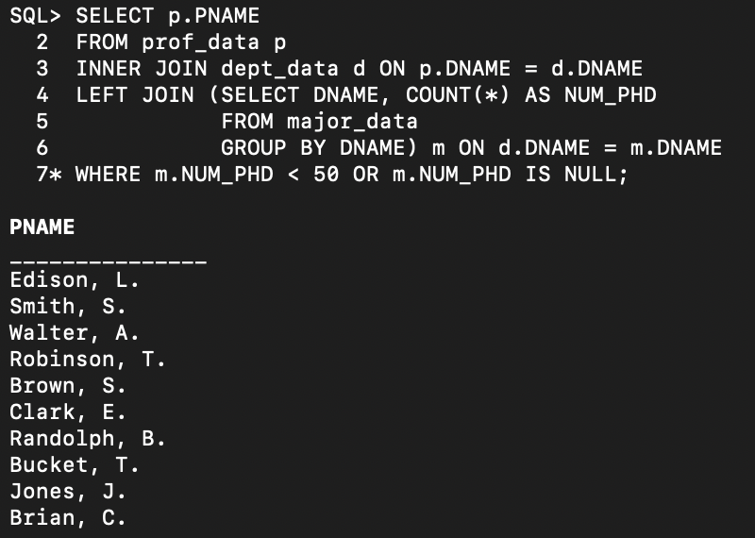

**Question 2**:

SELECT SNAME

FROM student_data

WHERE GPA = (SELECT MIN(GPA) FROM student_data);

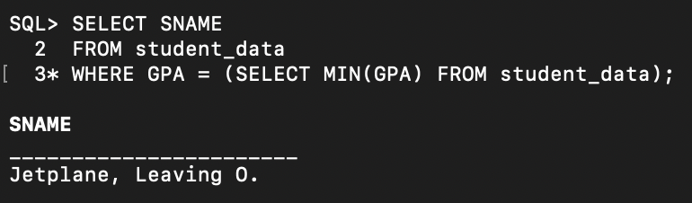

**Question 3**:

SELECT

s.CNO AS ClassNumber,

s.SEC_NO AS SectionNumber,

AVG(GPA) AS AverageGPA

FROM

section_data s

INNER JOIN

course_data c ON s.CNO = c.CNO

LEFT JOIN

enroll_data e ON s.CNO = e.CNO AND s.SEC_NO = e.SEC_NO

LEFT JOIN

student_data sd ON e.SID = sd.SID

WHERE

c.DNAME = 'Computer Sciences'

GROUP BY

s.CNO, s.SEC_NO

ORDER BY

s.CNO, s.SEC_NO;

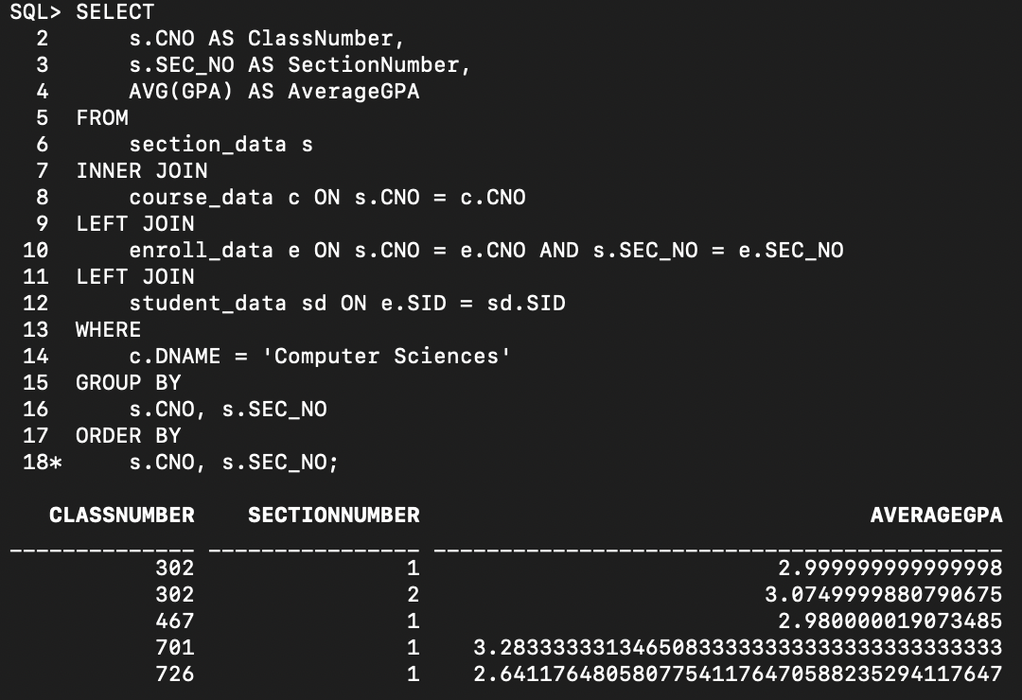

**Question 4**:

SELECT

s.PNAME AS ProfessorName,

s.SEC_NO AS SectionNumber

FROM

section_data s

LEFT JOIN

enroll_data e ON s.CNO = e.CNO AND s.SEC_NO = e.SEC_NO

GROUP BY

s.PNAME, s.SEC_NO

HAVING

COUNT(e.SID) > 6

ORDER BY

s.SEC_NO;

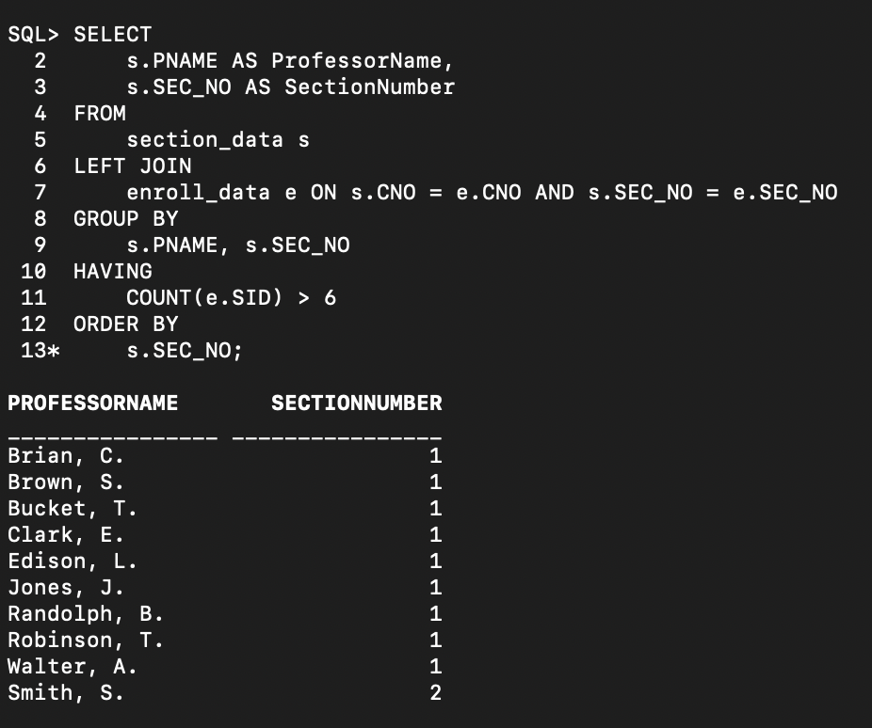

**Question 5**:

SELECT s.SID, st.SNAME

FROM (

SELECT SID, RANK() OVER (ORDER BY SectionCount DESC) AS rank

FROM (

SELECT e.SID, COUNT(*) AS SectionCount

FROM enroll_data e

GROUP BY e.SID

)

) s

JOIN student_data st ON s.SID = st.SID

WHERE s.rank = 1;

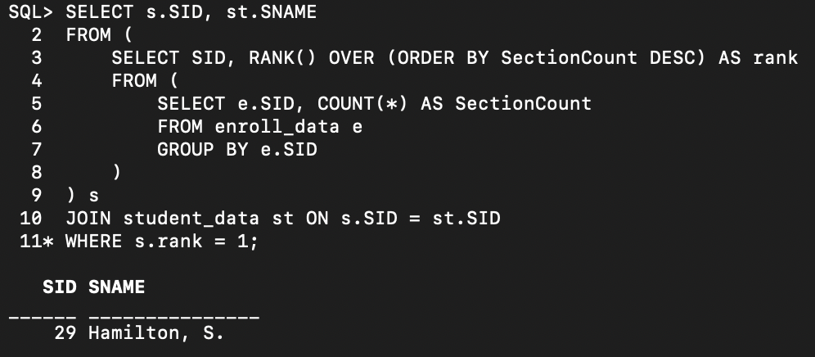

**Question 6**:

SELECT DISTINCT d.DNAME

FROM dept_data d

WHERE EXISTS (

SELECT 1

FROM major_data m

JOIN student_data s ON m.SID = s.SID

WHERE d.DNAME = m.DNAME AND s.AGE < 18

);

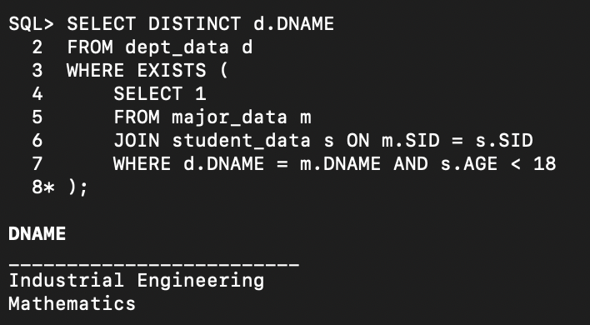

**Question 7**:

SELECT DISTINCT s.SNAME, m.DNAME AS Major

FROM student_data s

JOIN major_data m ON s.SID = m.SID

JOIN enroll_data e ON s.SID = e.SID

JOIN section_data sec ON e.CNO = sec.CNO AND e.SEC_NO = sec.SEC_NO

JOIN course_data c ON sec.CNO = c.CNO

WHERE c.CNAME LIKE '%Geometry%';

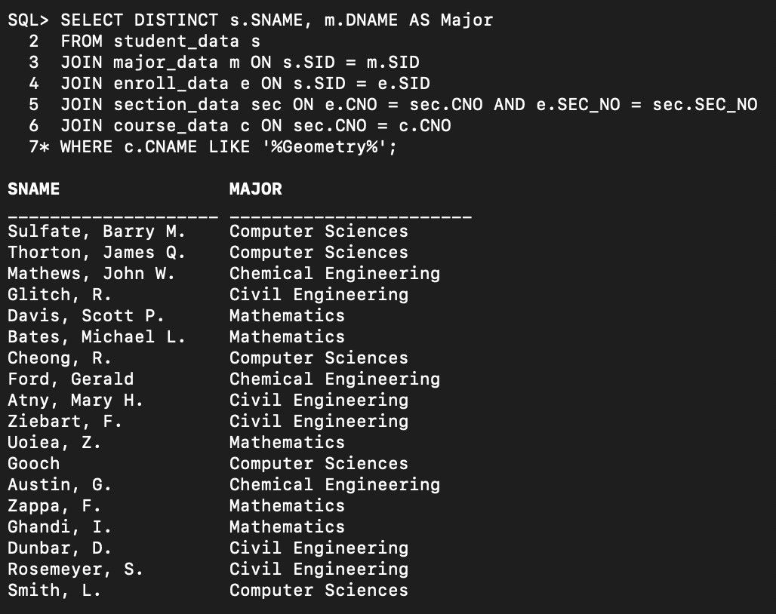

**Question 8**:

SELECT

d.DNAME AS DepartmentName,

NVL(d.NUM_PHD, 0) AS NumPhDStudents

FROM

dept_data d

LEFT JOIN

(

SELECT DISTINCT m.DNAME

FROM major_data m

JOIN enroll_data e ON m.SID = e.SID

JOIN section_data sec ON e.CNO = sec.CNO AND e.SEC_NO = sec.SEC_NO

JOIN course_data c ON sec.CNO = c.CNO

WHERE c.CNAME LIKE '%Geometry%'

) geometry_depts

ON

d.DNAME = geometry_depts.DNAME

WHERE

geometry_depts.DNAME IS NULL;

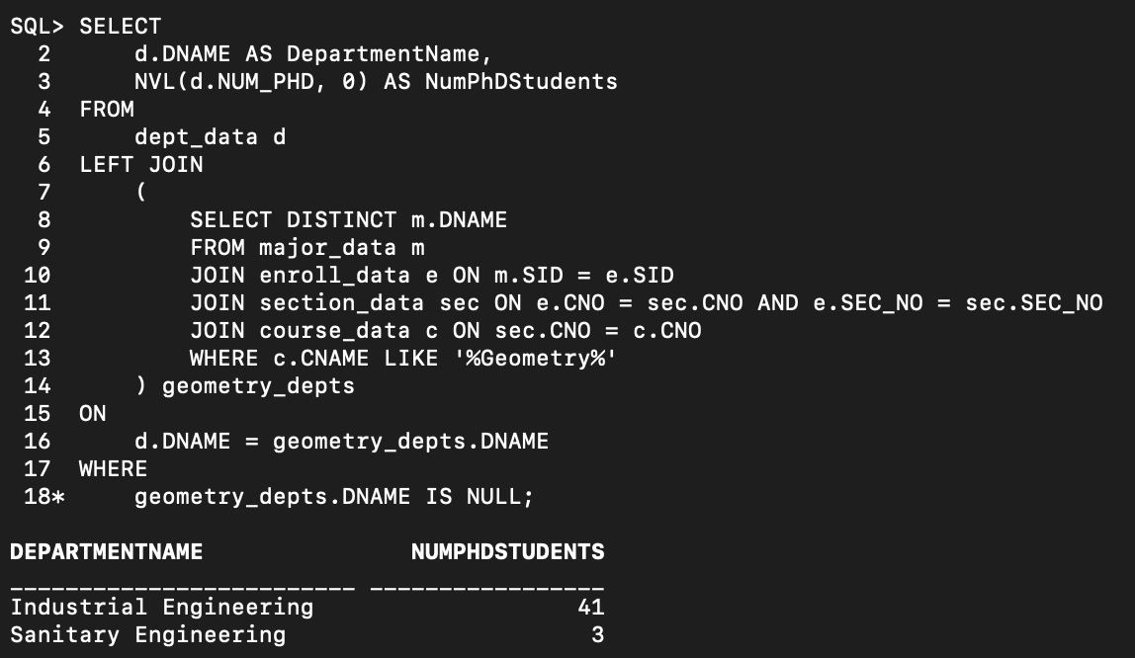

**Question 9**:

SELECT DISTINCT s.SNAME

FROM student_data s

WHERE s.SID IN (

SELECT m.SID

FROM major_data m

JOIN enroll_data e ON m.SID = e.SID

JOIN section_data sec ON e.CNO = sec.CNO AND e.SEC_NO = sec.SEC_NO

JOIN course_data c ON sec.CNO = c.CNO

WHERE m.DNAME = 'Computer Sciences'

)

AND s.SID IN (

SELECT m.SID

FROM major_data m

JOIN enroll_data e ON m.SID = e.SID

JOIN section_data sec ON e.CNO = sec.CNO AND e.SEC_NO = sec.SEC_NO

JOIN course_data c ON sec.CNO = c.CNO

WHERE m.DNAME = 'Mathematics'

);

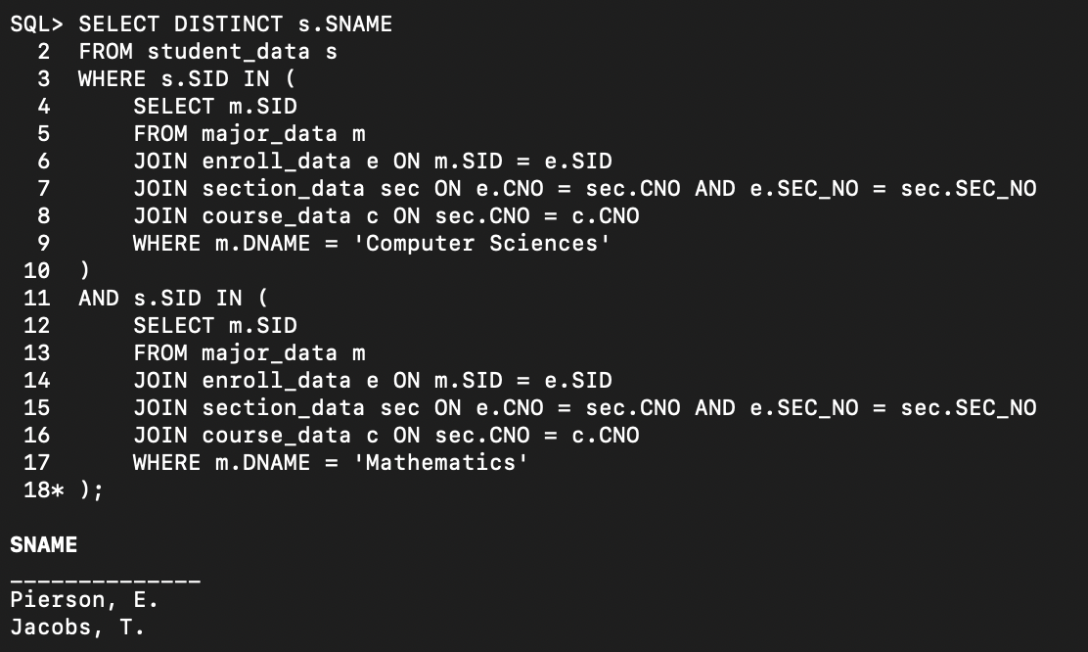

**Question 10**:

SELECT MAX(s.AGE) - MIN(s.AGE) AS AgeDifference

FROM student_data s

WHERE s.SID IN (

SELECT m.SID

FROM major_data m

WHERE m.DNAME = 'Computer Sciences'

);

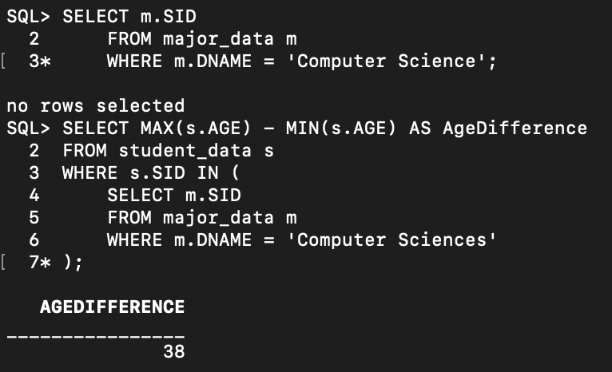

**Question 11**:

SELECT

d.DNAME AS DepartmentName,

AVG(s.GPA) AS AverageGPA

FROM

dept_data d

JOIN

major_data m ON d.DNAME = m.DNAME

JOIN

student_data s ON m.SID = s.SID

WHERE

s.GPA < 1.0

GROUP BY

d.DNAME

HAVING

COUNT(DISTINCT m.SID) > 0;

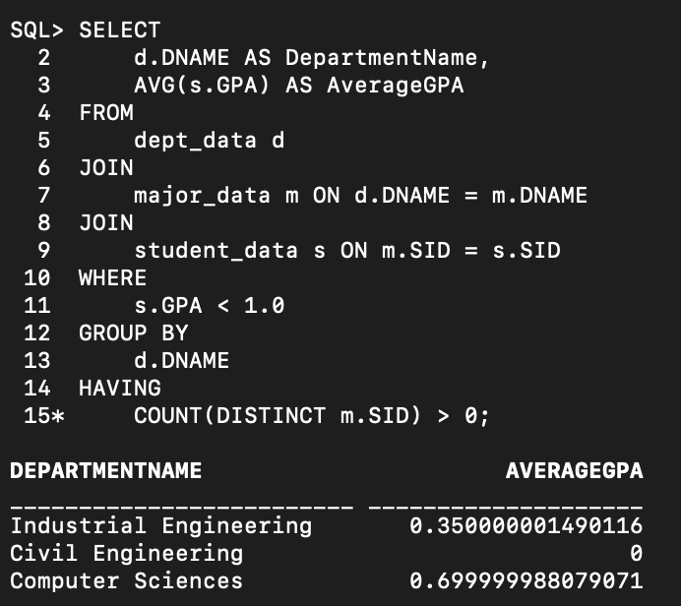

**Question 12**:

SELECT s.SID, s.SNAME, s.GPA

FROM student_data s

WHERE s.SID IN (

SELECT e.SID

FROM enroll_data e

WHERE e.CNO IN (

SELECT CNO

FROM course_data

WHERE DNAME = 'Civil Engineering'

)

GROUP BY e.SID

HAVING COUNT(DISTINCT e.CNO) = (

SELECT COUNT(DISTINCT CNO)

FROM course_data

WHERE DNAME = 'Civil Engineering'

)

);

